**Exercise on Arithmetic and Logical operations in computer vision using MATLAB**

**TASK-2**

**EXERCISE 1: IMAGE ADDITION AND SUBTRACTION**

**Code**

image1 = imread("moon.tif");

image2 = imread("cameraman.tif");

size1 = size(image1);

size2 = size(image2);

image2 = imresize(image2, size1);

additionResult = image1 + image2;

subtractionResult = image1 - image2;

figure;

subplot(2, 2, 1);

imshow(image1);

title('Image1');

subplot(2, 2, 2);

imshow(image2);

title('Image2');

subplot(2, 2, 3);

imshow(additionResult);

title('added image');

subplot(2, 2, 4);

imshow(subtractionResult);

title('subtracted image')

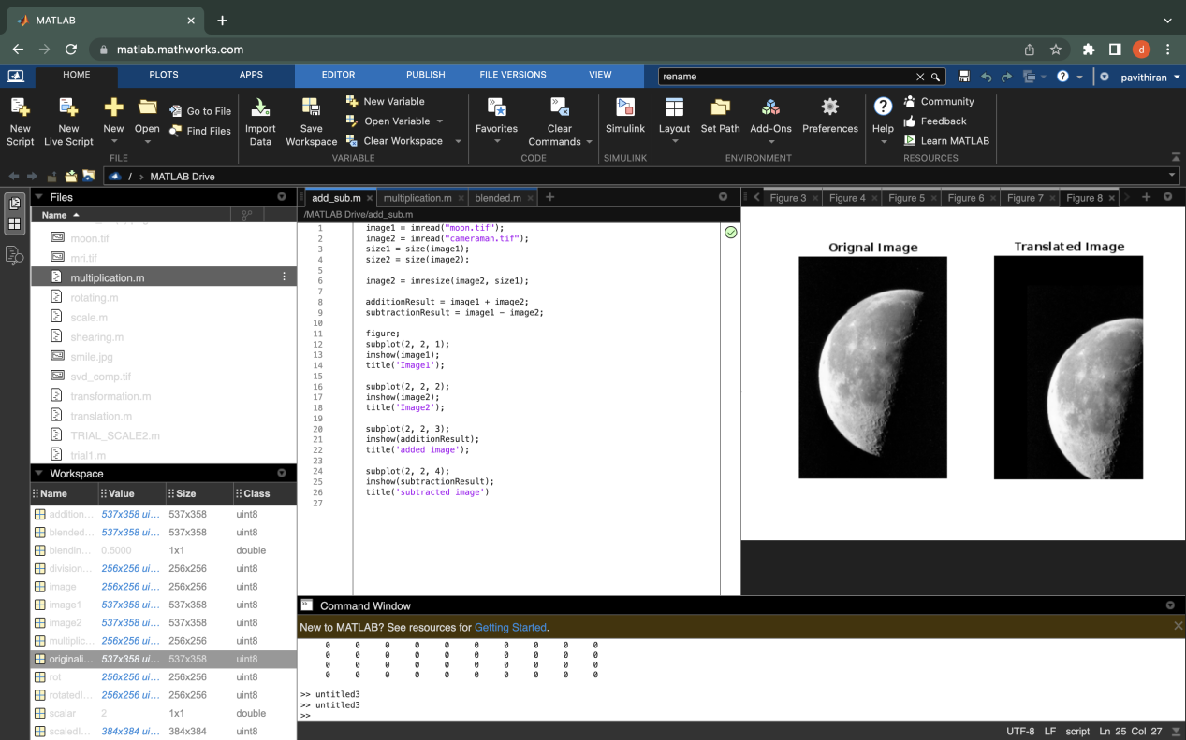

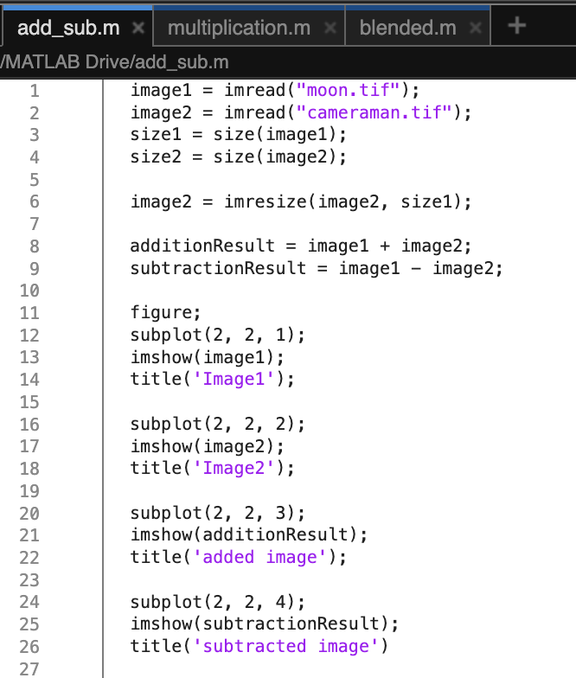

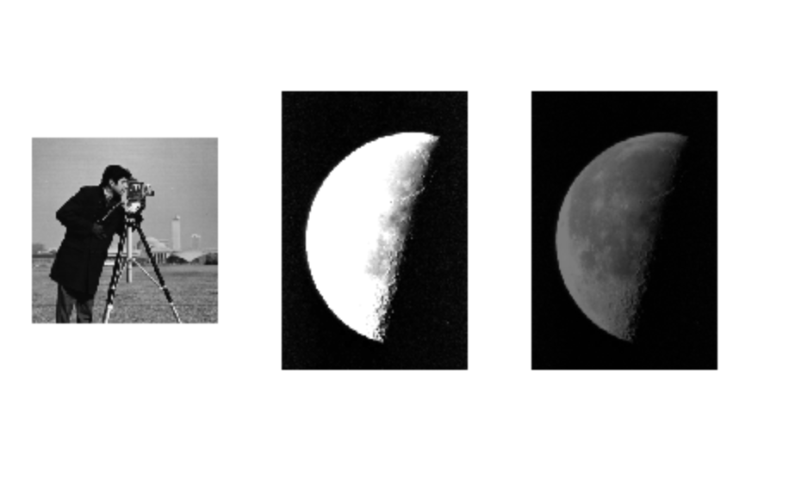

**EXERCISE 2: IMAGE MULTIPLICATION AND DIVISION**

**CODE**

image1 = imread("cameraman.tif");

scalar = 2;

multiplicationResult = image1 * scalar;

divisionResult = image1/scalar;

figure;

subplot(1,3,1);

imshow(image1);

title('Original image')

subplot(1, 3, 2);

imshow(multiplicationResult)

title('multiplied')

subplot(1, 3, 3);

imshow(divisionResult);

title('divided')

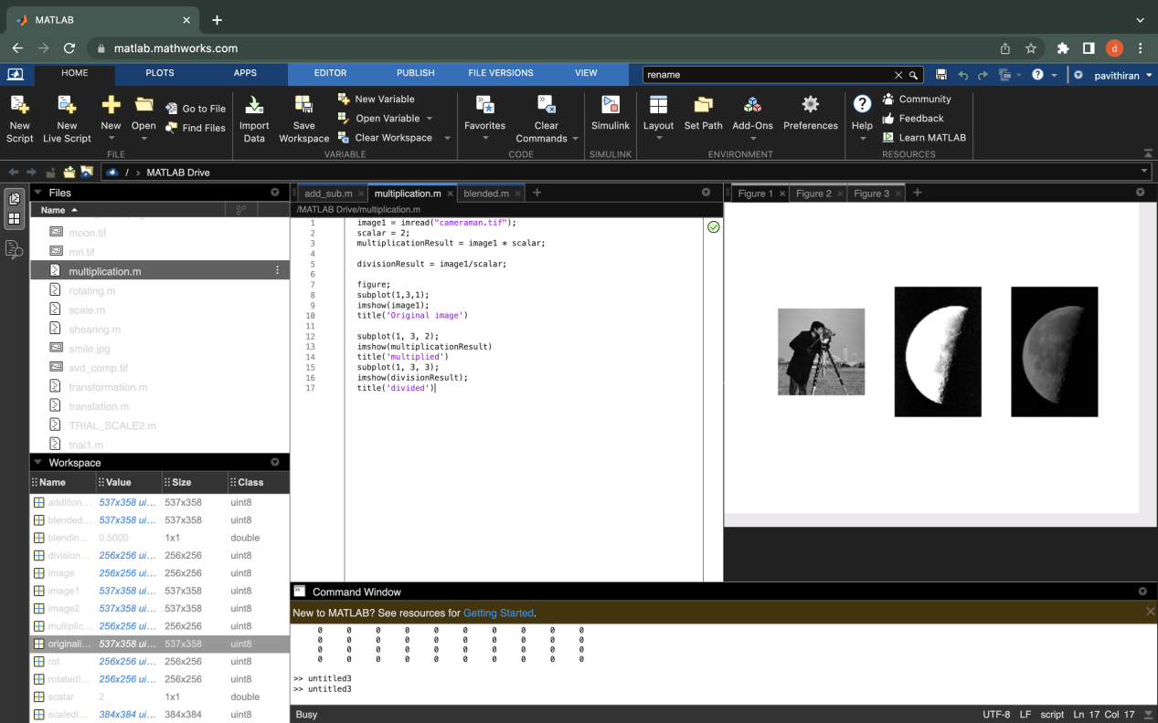

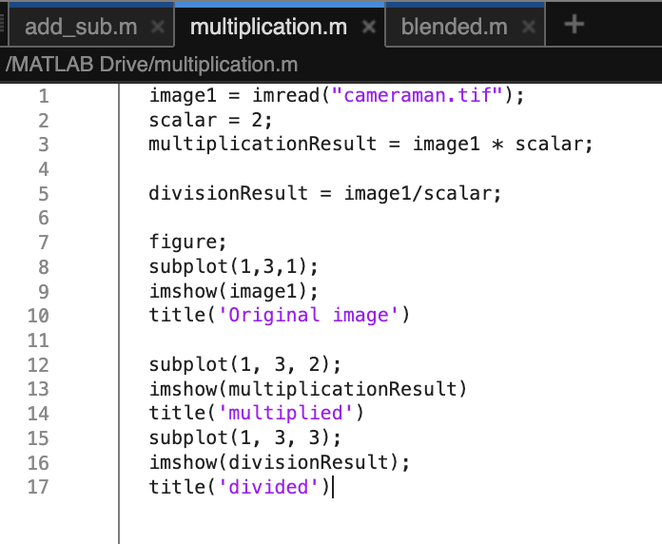

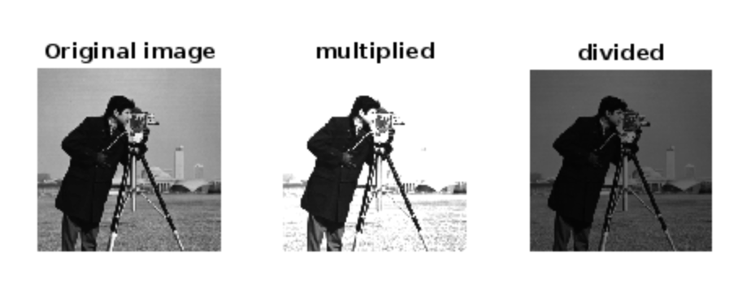

**EXERCISE 5: IMAGE BLENDING**

**Code**

image1 = imread("moon.tif");

image2 = imread("cameraman.tif");

image2 = imresize(image2, size(image1));

blendingRatio = 0.5;

blendedImage = blendingRatio * image1 +(1 - blendingRatio) * image2;

figure;

subplot(1, 3, 1);

imshow(image1);

title('image1');

subplot(1, 3, 2);

imshow(image2);

title('image2')

subplot(1,3, 3);

imshow(blendedImage)

title('blendedImage')

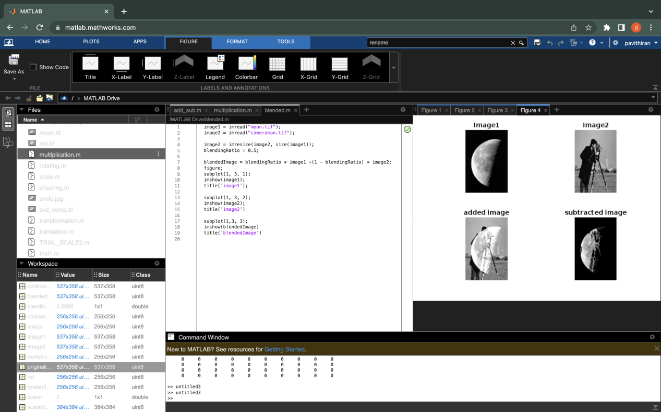

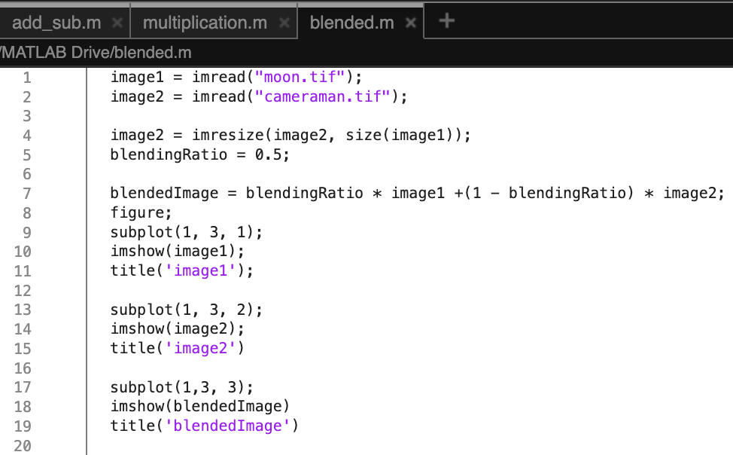

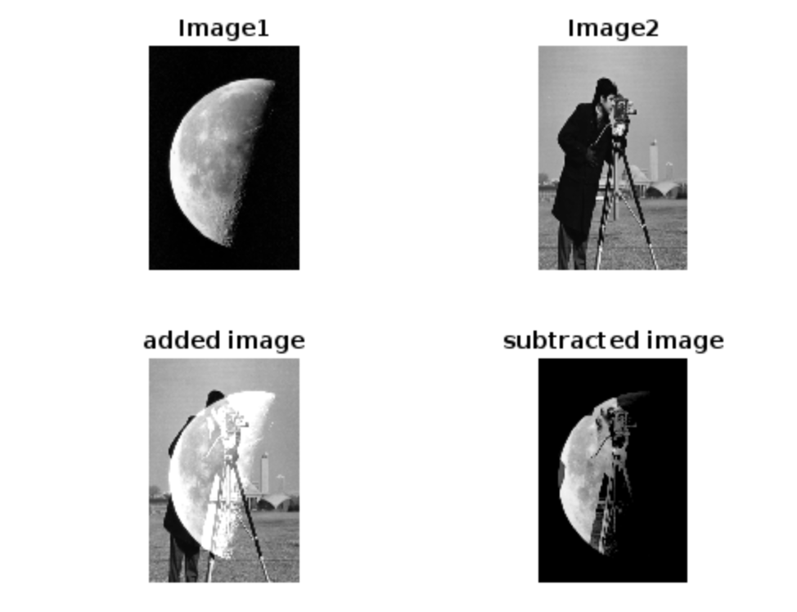

**EXERCISE 6: IMAGE INVERSION**

image = imread('cameraman.tif');

inverted_image = imcomplement(image);

figure;

subplot(1, 2, 1);

imshow(image);

title('Original Image')

subplot(1, 2, 2);

imshow(inverted_image);

title('Inverted Image');

